Tools Programming
Tutorial 7: Picking

Why this is important

This tutorial covers picking for object selection in our tool. Picking is a huge step forward in functionality and usability as it’s completely intuitive to move a mouse to the object we want to interact with and select it. This is an important technique as it’s used again and again in games and tools.

What you need to know

Picking can be broken down into two stages:

- Determine the picking point and construct a 3D ray in the scene from this point

- Use this ray to perform a Ray-object intersection test on the scene objects to determine which of them it hits

In our case, the second part is the easiest. As we are using the DirectX mesh object from the direct X tool Kit, it already comes loaded with functionality to handle the actual intersection test. So really, our problem to solve is the creation of the picking point and the application of that into our list of scene objects.

So conceptually we have our scene viewed on the screen and we want to mouse over a visible object. This is projection space.

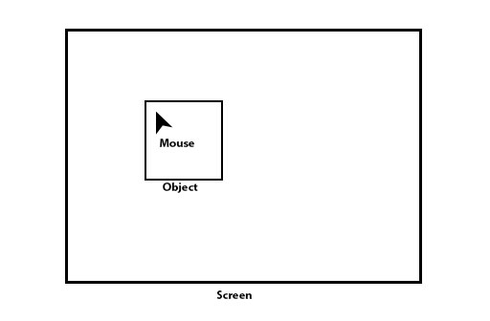

If we move into an external view of the scene in viewspace we have the following

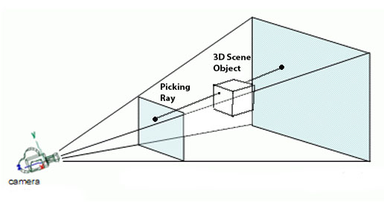

Our selected point on the screen traces a ray in 3D space through the scene and can be seen to intersect the object we are interested in. So conceptually keep this in mind.

However, remember that the scene is only transformed into this space as part of the graphics pipeline which exists entirely on the GPU, the rest of the time our objects are untransformed existing only with their own local space.

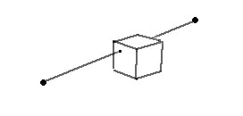
Figure 1: Expectation
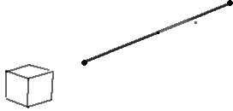
Figure 2: Reality with object in Local space

So in order to check collision with the object vs the ray, we would have to re-transform the object into the correct position respective to the ray and perform the collision check. Luckily there is a better way of doing this.

Instead of transforming every object back into viewspace we will transform our ray and UNPROJECT it back into the objects local space!

This is much more efficient as for every object, we only need to transform the ray (two points) rather than the entire object to perform the collision.

So what we need to do is:

- Find the screen Space coordinates of the point clicked
- Convert this into a point on the near and far plane of the view frustrum
- Obtain the transforms for the object which are used to position and view it in the scene.
- Using these transforms. UNPROJECT the picking points back into the objects local space.
- Create a vector between the two transformed points.
- Perform the intersection test between the vector and the object.

Do not worry about the UNPROJECT transform, this functionality is provided from directX as it’s a commonly performed calculation it has its own functionality from the SDK.

To achieve this we will be working in two sections of the framework.

In game.cpp and game.h we will create the picking method. Picking is reliant on scene information so it has everything we need in order to perform the picking check geometrically.

In ToolMain we will call the picking function and pass it the mouse x / y and have the selected object ID returned to us.

Tasks:

Task 1:

Firstly: make a new method in your renderer class in Game.cpp / Game.h

int MousePicking();

with the definition in the c++:

int Game::MousePicking()
{
return 0;
}

The picking function will be called from toolmain, and return the ID of the object that has been picked.

We require some extra information to be recorded and passed down to the renderer, namely the mouse position. Since game.cpp already has access to the “input commands” object lets add some extra variables in there. (inputcommands.h)

int mouse_X;
int mouse_Y;
bool mouse_LB_Down;

These are already passed down to the renderer in the toolmain::tick method into the renderers tick method. So as soon as we add these new values, its automatically sent down to the renderer.

Note: Please remember to INITIALISE these values to something in the toolmain constructor along with the other variables from the input commands object

Task 2:

Our next alteration is in toolmain::update input. And toolmain::tick

We must make sure we are getting the mouse position and mousebutton status:

case WM_MOUSEMOVE:
//update the mouse X and Y which will be sent thru to the Renderer.
m_toolInputCommands.mouse_X = GET_X_LPARAM(msg->lParam);
m_toolInputCommands.mouse_Y = GET_Y_LPARAM(msg->lParam);
break;

case WM_LBUTTONDOWN:
//mouse left pressed.
m_toolInputCommands.mouse_LB_Down = true;
break;

Next in toolmain::tick we will add in the command to pick from the scene if the mouse button is pressed.

if (m_toolInputCommands.mouse_LB_Down)
{
m_selectedObject = m_d3dRenderer.MousePicking();
m_toolInputCommands.mouse_LB_Down = false;
}

Task 3:

We need to make a couple of changes in game.h and game.cpp before we start working on the picking function.

Our picking operation requires the information about the windows client area. So we are going to add a new variable into our renderer class in game.h. A rect object so we can store the dimensions of the active window client area.

RECT m_ScreenDimensions;

In order to get this information, we need to know the handle to the current window. The renderer actually already uses the windows handle on setup. So we will add a line into the renderers initialise function to save the client area rect where we can use it later. Note. Add this line into initialise at the end of the setup functions

GetClientRect(window, &m_ScreenDimensions);

Task 4:

Lastly, we will add in the content of our picking function

int Game::MousePicking()
{
int selectedID = -1;
float pickedDistance = 0;

//setup near and far planes of frustum with mouse X and mouse y passed down from Toolmain.
//they may look the same but note, the difference in Z
const XMVECTOR nearSource = XMVectorSet(m_InputCommands.mouse_X, m_InputCommands.mouse_Y, 0.0f, 1.0f);
const XMVECTOR farSource = XMVectorSet(m_InputCommands.mouse_X, m_InputCommands.mouse_Y, 1.0f, 1.0f);

//Loop through entire display list of objects and pick with each in turn.
for (int i = 0; i < m_displayList.size(); i++)
{
//Get the scale factor and translation of the object
const XMVECTORF32 scale = { m_displayList[i].m_scale.x, m_displayList[i].m_scale.y, m_displayList[i].m_scale.z };
const XMVECTORF32 translate = { m_displayList[i].m_position.x, m_displayList[i].m_position.y, m_displayList[i].m_position.z };

//convert euler angles into a quaternion for the rotation of the object
XMVECTOR rotate = Quaternion::CreateFromYawPitchRoll( m_displayList[i].m_orientation.y *3.1415 / 180, m_displayList[i].m_orientation.x *3.1415 / 180,
m_displayList[i].m_orientation.z *3.1415 / 180);

//create set the matrix of the selected object in the world based on the translation, scale and rotation.
XMMATRIX local = m_world * XMMatrixTransformation(g_XMZero, Quaternion::Identity, scale, g_XMZero, rotate, translate);

//Unproject the points on the near and far plane, with respect to the matrix we just created.
XMVECTOR nearPoint = XMVector3Unproject(nearSource, 0.0f, 0.0f, m_ScreenDimensions.right, m_ScreenDimensions.bottom, m_deviceResources->GetScreenViewport().MinDepth, m_deviceResources->GetScreenViewport().MaxDepth, m_projection, m_view, local);

XMVECTOR farPoint = XMVector3Unproject(farSource, 0.0f, 0.0f, m_ScreenDimensions.right, m_ScreenDimensions.bottom, m_deviceResources->GetScreenViewport().MinDepth, m_deviceResources->GetScreenViewport().MaxDepth, m_projection, m_view, local);

//turn the transformed points into our picking vector.
XMVECTOR pickingVector = farPoint - nearPoint;
pickingVector = XMVector3Normalize(pickingVector);

//loop through mesh list for object
for (int y = 0; y < m_displayList[i].m_model.get()->meshes.size(); y++)
{
//checking for ray intersection
if (m_displayList[i].m_model.get()->meshes[y]->boundingBox.Intersects(nearPoint, pickingVector, pickedDistance))
{
selectedID = i;
}
}
}

//if we got a hit. return it.
return selectedID;
}

I have attached this in a CPP file in the project in case its hard to read.

Take the time to go through this line by line so that you can see what information is being used and how.

If all has gone well you should be able to move around, pick objects and see the status indicator in the bottom of the screen change as you select objects.

Whats Next?

This example provides functional picking for a single object and will return the first object hit in the picking check. This is not functionally correct. It’s checking the picking in the order that the objects are specified in the display list. This means that an object checked first that’s behind the object we are checking will actually register the hit.

So, you need to check all objects then only update the selected object when something CLOSER than the previously hit selection registers and work through all objects till you find the closest hit and THAT is the object you want. Note that when we perform the picking check we also receive a distance! Therefor as you pick you need to store the current closest distance and compare the received distance from the latest hit and see if you need to update the currently selected object.

The other issue is that this is only working out a single collision. Its not handling de-selection (picking an already selected object) and not handling multiple selections if you want to make that a feature. Typically in 3d Applications, multiple selections are handled by holding a keypress while picking.

Having the picking function return a VECTOR of ints (all your selected objects) might be a good evolution.

